ACHARYA INSTITUTE OF GRADUATE STUDIES
(AFFILIATED TO BANGALORE UNIVERSITY)



Master of Computer Application

project Report on

“STUDENT RESUME READLINESS ANALYZER”

Under the guidance of

S RAJESH KUMAR

SUBMITTED BY
RAKSHITHA NL AF05051642
PREETHAM AF05051605
TEJAS REDDY AF05050982
CONTENTS

CHAPTER NUMBER TITLE

01 INTRODUCTION

02 DESIGN AND IMPLEMENTATION

03 FUNCTIONAL AND NON-FUNCTIONAL
REQUIREMENTS

04 SOFTWARE REQUIREMENTS

05 HIGH-LEVEL DESIGN (HLD) AND LOW-
LEVEL DESIGN (LLD)

06 TOOLS AND TECHNOLOGIES USED

07 SOFTWARE AND HARDWARE ENVIRONMENT

08 TESTING AND TEST CASES

09 DATA FLOW DIAGRAM (DFD)

10 CODING

Abstract

The Student Resume Readiness Analyzer is a console-based Java application designed to help students manage, organize, and evaluate their resume information effectively. The system provides a structured platform where users can register, log in, and maintain various components of their resume such as personal details, skills, projects, and certifications.
The application is developed using Core Java and JDBC for database connectivity, with MySQL as the backend database. It follows the DAO (Data Access Object) design pattern to ensure proper separation between business logic and database operations. A Connection Factory class is used to manage database connections efficiently. Each database table is represented using separate bean classes to maintain modularity and encapsulation.
The system allows users to perform full CRUD (Create, Read, Update, Delete) operations on all resume-related modules. It also uses SQL JOIN queries to retrieve complete resume details by combining data from multiple related tables. In addition, the resume analysis feature evaluates the readiness of a student’s resume based on the presence and number of skills, projects, and certifications, providing basic feedback for improvement.
This project demonstrates practical implementation of object-oriented programming concepts, database management, SQL queries, design patterns, and layered architecture. The Student Resume Readiness Analyzer serves as an academic-level system that helps students assess and improve their resume quality in preparation for job and internship opportunities.

ER Diagram Structure

USER
-----
user_id (PK)
username
password
|
| 1:1
|
STUDENT
-------
student_id (PK)
user_id (FK)
name
email
phone
|
| 1:M
|
-----------------------------------------
| | |
SKILL PROJECT CERTIFICATION
------ -------- --------------
skill_id(PK) project_id(PK) cert_id(PK)
student_id(FK) student_id(FK) student_id(FK)
skill_name title cert_name
level description organization
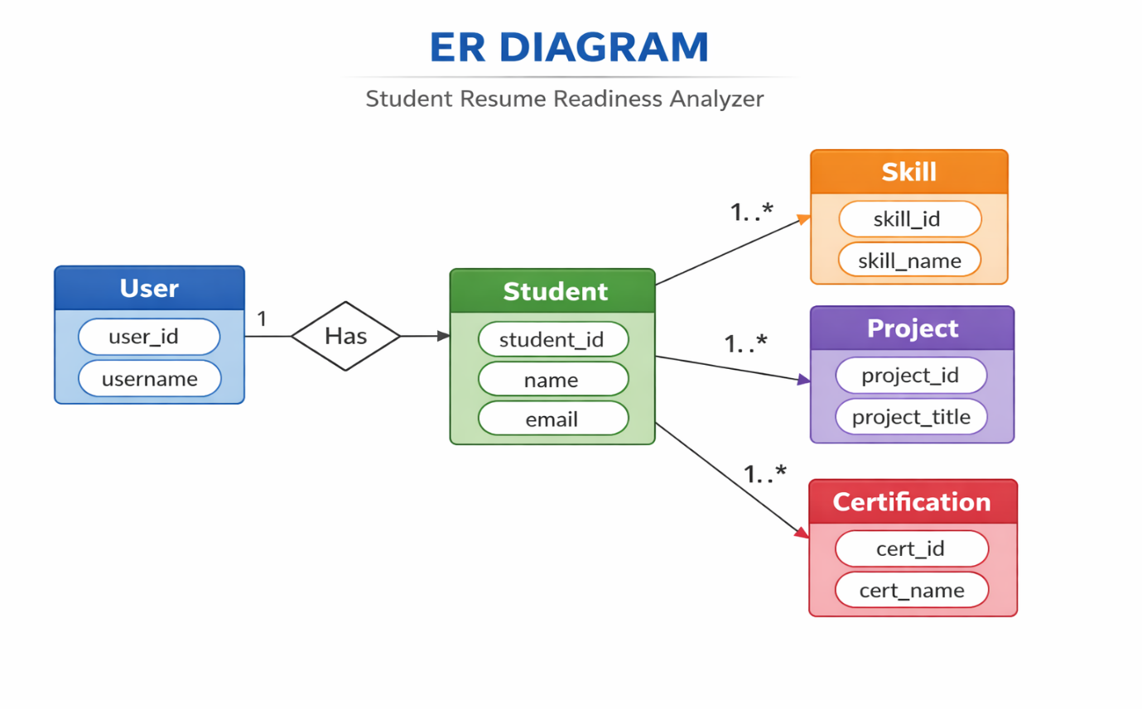

CHAPTER 01

INTRODUCTION

1.1 Overview of the Project
In today’s competitive academic and professional environment, a well-structured and strong resume plays a crucial role in securing internships and job opportunities. Many students struggle to evaluate whether their resume meets industry expectations. To address this issue, the Student Resume Readiness Analyzer has been developed as a console-based Java application that helps students manage and analyze their resume information efficiently.
The system provides a centralized platform where students can register, log in, and maintain essential resume components such as personal details, skills, projects, and certifications. It also includes a resume analysis feature that evaluates the completeness of a resume and provides feedback based on predefined criteria.

1.2 Need for the System
Traditionally, students prepare resumes manually without any structured evaluation. Common issues include:
- Missing important sections such as certifications or projects
- Insufficient number of technical skills
- Poor organization of resume information
- No feedback mechanism to evaluate resume strength
The Student Resume Readiness Analyzer solves these problems by:
- Providing a structured database-driven system
- Allowing organized storage of resume data
- Enabling easy modification through CRUD operations
- Analyzing resume completeness automatically

1.3 Purpose of the Project
The purpose of this project is to:
- Develop a console-based application using Core Java
- Implement database connectivity using JDBC
- Apply DAO (Data Access Object) design pattern
- Use SQL JOIN queries to fetch complete resume data
- Provide resume analysis based on stored information
The system ensures proper separation between user interface, business logic, and database operations.

1.4 Technologies Used
The project is implemented using the following technologies:
- Core Java
- JDBC (Java Database Connectivity)
- MySQL Database
- DAO Design Pattern
- Factory Design Pattern
- SQL (Structured Query Language)
These technologies help in building a modular, maintainable, and scalable application.

1.5 Features of the System
The major features of the system include:
- User Registration and Login
- Student Profile Management
- Skill Management
- Project Management
- Certification Management
- Full CRUD Operations
- Resume View using JOIN Queries
- Resume Readiness Analysis

1.6 Structure of the Project
The application follows a layered architecture:
- Presentation Layer (Main Class – Console Interaction)
- Business/Data Access Layer (DAO Interfaces and Implementations)
- Database Layer (MySQL Database)
Each database table is represented by a separate bean class to ensure modular design.

1.7 Conclusion of Introduction
The Student Resume Readiness Analyzer provides a structured and systematic way for students to manage and evaluate their resume information. It demonstrates the practical application of object-oriented programming, database integration, and design patterns. The system serves as a foundational academic project that can be extended into a full-scale resume management and career guidance platform in the future.

CHAPTER 02
DESIGN AND IMPLEMENTATION

2.1 System Design
The Student Resume Readiness Analyzer is designed using a layered architecture approach to ensure modularity, maintainability, and scalability. The system separates user interaction, business logic, and database operations into different layers.
The overall architecture consists of three main layers:
- Presentation Layer
- Business/Data Access Layer
- Database Layer
This separation ensures clean code organization and easy maintenance.

2.1.1 Presentation Layer
The Presentation Layer consists of the Main Class, which provides a console-based interface for user interaction.
Responsibilities:
- Displaying menu options using switch-case
- Handling user input using Scanner
- Managing registration and login
- Calling DAO methods for CRUD operations
- Navigating between modules
The user interacts with the system through menu-driven options such as:
- Register
- Login
- Student CRUD
- Skill CRUD
- Project CRUD
- Certification CRUD
- View Resume
- Analyze Resume

2.1.2 Business / Data Access Layer
This layer contains:
A) Bean Classes
Each database table is represented by a separate bean class:
- User
- Student
- Skill
- Project
- Certification
Features of Bean Classes:
- Private variables (encapsulation)
- Public getters and setters
- Represent table structure
- Store object data temporarily

B) DAO Interfaces
DAO (Data Access Object) interfaces define abstract methods for database operations such as:
- add()
- update()
- delete()
- getAll()
- login()
- register()
Purpose:
- Define standard operations
- Reduce code dependency
- Improve flexibility

C) DAO Implementation Classes
DAO Implementation classes contain:
- SQL queries
- JDBC code
- PreparedStatement usage
- Exception handling
They perform:
- INSERT operations
- UPDATE operations
- DELETE operations
- SELECT operations
- JOIN queries for resume viewing

2.1.3 Database Layer
The system uses MySQL as the backend database.
Tables used:
- users
- students
- skills
- projects
- certifications
Relationships:
- One User → One Student
- One Student → Many Skills
- One Student → Many Projects
- One Student → Many Certifications
Foreign keys maintain referential integrity.

2.2 Design Patterns Used
2.2.1 DAO Design Pattern
The DAO pattern separates database logic from business logic.
Advantages:
- Easy maintenance
- Code reusability
- Loose coupling
- Better organization

2.2.2 Factory Design Pattern
A Connection Factory class is used to manage database connections.
Advantages:
- Centralized connection handling
- Avoids repeated connection code
- Improves maintainability

2.3 Implementation Details
2.3.1 User Authentication
- Users register with username and password.
- Login is verified using database validation.
- PreparedStatement prevents SQL injection.

2.3.2 CRUD Operations
The system implements full CRUD operations for:
- Student
- Skill
- Project
- Certification
Operations include:
- Create (Insert new records)
- Read (View records)
- Update (Modify existing records)
- Delete (Remove records)

2.3.3 Resume View (JOIN Queries)
JOIN queries combine multiple tables to generate complete resume information.
Example:
- Student + Skills
- Student + Projects
- Student + Certifications
This allows structured resume display in a single view.

2.3.4 Resume Analysis Module
The Resume Analysis module evaluates resume readiness based on:
- Number of skills
- Number of projects
- Number of certifications
Basic evaluation logic:
- Less than required skills → Needs improvement
- No certifications → Add certifications
- Insufficient projects → Add more practical experience
This provides automated feedback to students.

2.4 Advantages of the System Design
- Modular architecture
- Clean separation of concerns
- Easy debugging
- Scalable structure
- Secure database operations
- Industry-standard design pattern usage

2.5 Limitations
- Console-based interface (no GUI)
- Basic analysis logic
- No PDF resume generation
- No cloud deployment

2.6 Conclusion
The design and implementation of the Student Resume Readiness Analyzer follow structured software engineering principles. By applying layered architecture, DAO design pattern, and JDBC integration, the system ensures maintainability, scalability, and efficient database management. The implementation demonstrates practical understanding of core Java concepts and database-driven application development.

Chapter 3
Functional and Non-Functional Requirements

3.1 Functional Requirements
Functional requirements describe what the system should do. These are the core features and operations of the Student Resume Readiness Analyzer.

1 User Management
- The system shall allow users to register with a username and password.
- The system shall allow registered users to log in.
- The system shall validate login credentials from the database.
- The system shall allow users to logout securely.

2 Student Profile Management
- The system shall allow users to create a student profile.
- The system shall allow users to view student details.
- The system shall allow users to update student information.
- The system shall allow users to delete student records.

3 Skill Management
- The system shall allow users to add skills.
- The system shall allow users to update skills.
- The system shall allow users to delete skills.
- The system shall display all skills associated with a student.

4 Project Management
- The system shall allow users to add project details.
- The system shall allow users to update project information.
- The system shall allow users to delete projects.
- The system shall retrieve projects using database queries.

5 Certification Management
- The system shall allow users to add certifications.
- The system shall allow users to update certification details.
- The system shall allow users to delete certifications.
- The system shall display certifications linked to a student.

6 Resume Viewing
- The system shall generate a complete resume view.
- The system shall use JOIN queries to fetch data from multiple tables.
- The system shall display student, skill, project, and certification details together.

7 Resume Analysis
- The system shall analyze resume completeness.
- The system shall count number of skills, projects, and certifications.
- The system shall provide feedback based on predefined rules.
- The system shall indicate whether the resume is ready or needs improvement.

3.2 Non-Functional Requirements
Non-functional requirements describe how the system should perform.

1 Performance Requirements
- The system should retrieve data efficiently using optimized SQL queries.
- CRUD operations should execute within minimal response time.
- The system should handle multiple records without performance degradation.

2 Security Requirements
- The system should validate user login credentials.
- The system should use PreparedStatement to prevent SQL injection.
- Only authenticated users should access resume data.

3 Usability Requirements
- The system should provide a simple menu-driven console interface.
- The system should display clear instructions to the user.
- The system should show success and error messages properly.

4 Reliability Requirements
- The system should maintain data consistency.
- The system should handle exceptions properly.
- Database connection failures should be managed using try-catch blocks.

5 Maintainability Requirements
- The system should follow DAO design pattern.
- The system should use separate bean classes for each table.
- The system should allow easy modification of SQL queries.
- Code structure should support future enhancements.

6 Portability Requirements
- The system should run on any platform that supports Java (Windows, Linux, Mac).
- It should work with any MySQL-supported environment.

7 Scalability Requirements
- The system design should allow adding new modules easily.
- The database structure should support large data expansion.
- Future features like GUI or web version can be integrated.

Summary
The functional requirements define the system’s features such as login, CRUD operations, resume viewing, and analysis. The non-functional requirements ensure the system is secure, reliable, maintainable, and efficient.

Chapter 4

Software Requirements
The software requirements define the tools, technologies, and software environment needed to develop and run the Student Resume Readiness Analyzer application.

1 Development Software Requirements
The following software tools are required for developing the application:
• Programming Language
- Java (JDK 8 or above)
Used to develop the console-based application.
• IDE (Integrated Development Environment)
- Eclipse / IntelliJ IDEA / NetBeans
Used for writing, compiling, and debugging Java code.
• Database
- MySQL Server
Used to store user and resume data.
• Database Management Tool
- MySQL Workbench / phpMyAdmin
Used to create tables and manage database records.
• JDBC Driver
- MySQL Connector/J
Used to connect Java application with MySQL database.

2 Runtime Software Requirements
The following software must be installed on the system to run the application:
- Java Runtime Environment (JRE)
- MySQL Server running
- Properly configured database schema

3 Operating System Requirements
The system is platform-independent and can run on:
- Windows
- Linux
- macOS
As long as Java and MySQL are installed, the application can execute successfully.

4 Browser Requirement
Notapplicable.
The project is a console-based application and does not require a web browser.

5 Software Configuration
- Database Name: resume_analyzer
- Required Tables:
  - users
  - students
  - skills
  - projects
  - certifications
- Database connection configured in ConnectionFactory class.

Summary
The Student Resume Readiness Analyzer requires basic development tools such as Java, MySQL, and an IDE. Since it uses open-source technologies, it is cost-effective and easy to set up. The system is lightweight and does not require high-end software infrastructure.

Chapter 5

High-Level Design (HLD) and Low-Level Design (LLD)

1. High-Level Design (HLD)
High-Level Design describes the overall system architecture, major components, and how they interact with each other. It gives a broad view of the system without going into coding-level details.

1.1 Overall Architecture
The Student Resume Readiness Analyzer follows a layered architecture:
User (Console Interface)
↓
Main Class (Presentation Layer)
↓
DAO Layer (Business/Data Access Layer)
↓
Database (MySQL)

1.2 Major Modules
The system is divided into the following main modules:
1 User Module
- Registration
- Login
- Authentication
2 Student Module
- Add student details
- Update student details
- Delete student details
- View student profile
3 Skill Module
- Add skills
- Update skills
- Delete skills
4 Project Module
- Add projects
- Update projects
- Delete projects
5 Certification Module
- Add certifications
- Update certifications
- Delete certifications
6 Resume Module
- View complete resume (using JOIN queries)
- Analyze resume readiness

1.3 Database Design Overview
Tables Used:
- users
- students
- skills
- projects
- certifications
Relationships:
- One User → One Student
- One Student → Many Skills
- One Student → Many Projects
- One Student → Many Certifications

1.4 Design Patterns Used
- DAO Design Pattern (for database operations)
- Factory Design Pattern (for database connection)

1.5 High-Level Advantages
- Modular design
- Easy to maintain
- Scalable architecture
- Clear separation of responsibilities

2. Low-Level Design (LLD)
Low-Level Design explains the internal working of each module, including class structure, methods, database queries, and logic implementation.

2.1 Class-Level Design
Bean Classes
Each table has a corresponding bean class:
- User.java
- Student.java
- Skill.java
- Project.java
- Certification.java
Structure:
- Private variables
- Public getters and setters
- Default constructor
- Parameterized constructor (optional)

2.2 DAO Interface Design
Each entity has a DAO interface.
Example: StudentDAO
Methods:
- addStudent()
- updateStudent()
- deleteStudent()
- getAllStudents()
Purpose:
Defines database operations without implementation details.

2.3 DAO Implementation Design
Each DAO interface has an implementation class.
Example: StudentDAOImpl
Responsibilities:
- Write SQL queries
- Use PreparedStatement
- Handle exceptions
- Return boolean or object results
Example Query:
UPDATE students SET name=?, email=?, phone=? WHERE student_id=?

2.4 Connection Factory Design
ConnectionFactory class:
- Contains static method getConnection()
- Loads MySQL driver
- Returns database connection
- Centralizes connection logic
Benefits:
- Avoids duplicate connection code
- Easy maintenance

2.5 Resume View Logic (JOIN Queries)
The resume view uses JOIN queries like:
- Student JOIN Skills
- Student JOIN Projects
- Student JOIN Certifications
Purpose:
To display complete resume data in structured format.

2.6 Resume Analysis Logic
The system:
- Counts skills
- Counts projects
- Counts certifications
- Applies conditional rules
Example logic:
- If skills < 3 → Weak Resume
- If projects < 2 → Needs improvement
- If certifications = 0 → Add certifications

2.7 Menu Design (Main Class)
The main method:
- Uses switch-case
- Handles user input
- Calls DAO methods
- Controls program flow
Menu Structure:
- Register
- Login
- Exit
After login:
- Student CRUD
- Skill CRUD
- Project CRUD
- Certification CRUD
- View Resume
- Analyze Resume
- Logout

Difference Between HLD and LLD
High-Level Design | Low-Level Design
System overview | Detailed internal structure
Architecture focus | Class and method focus
Module interaction | Code-level implementation
No coding details | Includes SQL & logic

Conclusion
The High-Level Design defines the overall architecture and modules of the Student Resume Readiness Analyzer, while the Low-Level Design explains class structure, database interaction, and implementation logic. Together, they ensure a well-structured, maintainable, and scalable system.

CHAPTER 6

Tools and Technologies Used

1 Tools Used
Tools are the software applications used to develop, test, and manage the project.
• Integrated Development Environment (IDE)
- Eclipse / IntelliJ IDEA / NetBeans
Used for writing, compiling, and debugging Java code.
Provides features such as syntax highlighting, auto-completion, and project management.

• MySQL Workbench / phpMyAdmin
- Used for creating and managing the database.
- Helps in designing tables and executing SQL queries.
- Allows viewing and modifying stored data.

• MySQL Server
- Backend database server.
- Stores all resume-related data such as users, students, skills, projects, and certifications.
- Maintains relational database structure with foreign keys.

• JDK (Java Development Kit)
- Required to compile and run Java programs.
- Provides Java compiler (javac) and runtime environment.

2 Technologies Used
Technologies refer to the programming languages, frameworks, and concepts used in the project.

• Core Java
Used to:
- Implement business logic
- Handle user input (Scanner)
- Implement Object-Oriented Programming concepts
- Manage exception handling
Concepts used:
- Classes and Objects
- Encapsulation
- Inheritance (if applied)
- Interfaces
- Exception Handling

• JDBC (Java Database Connectivity)
Used to:
- Connect Java application to MySQL database
- Execute SQL queries
- Perform CRUD operations
- Handle database transactions
Features:
- PreparedStatement (prevents SQL injection)
- ResultSet (retrieves data)

• MySQL Database
Used to:
- Store user credentials
- Store student resume details
- Maintain relational structure
- Execute JOIN queries

• SQL (Structured Query Language)
Used for:
- INSERT statements
- UPDATE statements
- DELETE statements
- SELECT queries
- JOIN queries
JOIN queries help in displaying complete resume details by combining multiple tables.

• DAO (Data Access Object) Design Pattern
Used to:
- Separate database logic from business logic
- Improve maintainability
- Provide structured database operations

• Factory Design Pattern
Used in:
- ConnectionFactory class
- Centralized database connection management

3 Why These Tools & Technologies Were Chosen
- Java is platform-independent and widely used.
- MySQL is lightweight and easy to manage.
- JDBC provides reliable database connectivity.
- DAO pattern ensures clean architecture.
- Factory pattern improves code reusability.

Summary
The Student Resume Readiness Analyzer is developed using industry-standard tools and technologies such as Core Java, JDBC, MySQL, DAO Design Pattern, and Factory Pattern. These tools ensure the application is modular, maintainable, secure, and scalable.

Chapter 7
Software and Hardware Environment

1 Software Environment
The software environment defines the system software, development tools, and technologies required to develop and run the Student Resume Readiness Analyzer application.
1.1 Operating System
The application is platform-independent and can run on:
- Windows
- Linux
- macOS
As long as Java and MySQL are installed, the system can operate successfully.

1.2 Programming Language
- Java (JDK 8 or above)
Used for developing the console-based application.

1.3 Development Tools
- Eclipse / IntelliJ IDEA / NetBeans (IDE)
Used for coding, compiling, and debugging.
- MySQL Workbench / phpMyAdmin
Used for database creation and management.

1.4 Database
- MySQL Server
Used to store user and resume-related data.

1.5 Additional Software
- JDBC Driver (MySQL Connector/J)
Used to connect Java application with MySQL database.
- Java Runtime Environment (JRE)
Required to run the application.

2 Hardware Environment
The hardware environment defines the minimum system requirements needed to run the application.
2.1 Minimum Hardware Requirements
- Processor: Intel i3 or higher
- RAM: 4 GB minimum (8 GB recommended)
- Hard Disk: 10 GB free space
- Keyboard and Monitor

2.2 Recommended Hardware Configuration
- Processor: Intel i5 or above
- RAM: 8 GB or higher
- Hard Disk: 20 GB free space
- Stable power supply

3 Network Requirements
- No internet connection is required for basic functionality.
- Internet may be required for downloading dependencies or database setup.

Summary
The Student Resume Readiness Analyzer requires minimal hardware and uses open-source software technologies such as Java and MySQL. The system is lightweight, cost-effective, and can run on standard personal computers without requiring advanced infrastructure.

Chapter 08

Testing and Test Cases

Testing
Testing is the process of verifying that the system works as expected and meets the specified requirements. The Student Resume Readiness Analyzer was tested to ensure that all functionalities such as registration, login, CRUD operations, resume viewing, and resume analysis work correctly.

1.1 Types of Testing Performed
Unit Testing
- Each module (User, Student, Skill, Project, Certification) was tested individually.
- CRUD operations were tested separately.
Integration Testing
- Verified interaction between Main class and DAO layer.
- Tested JOIN queries for resume viewing.
- Checked database connectivity.
System Testing
- Entire application tested as a complete system.
- Verified menu navigation and overall workflow.
Validation Testing
- Checked input validation.
- Verified login credentials.
- Ensured error messages display properly.

2 Test Cases
Below are important test cases for the system:

Test Case 1 – User Registration
Test Case ID | TC_01
Module | User
Test Scenario | Register new user
Input | Valid username and password
Expected Result | User registered successfully
Actual Result | Success message displayed
Status | Pass

Test Case 2 – User Login (Valid Credentials)
Test Case ID | TC_02
Module | User
Test Scenario | Login with correct credentials
Input | Correct username and password
Expected Result | Login successful and menu displayed
Actual Result | Login successful
Status | Pass

Test Case 3 – User Login (Invalid Credentials)
Test Case ID | TC_03
Module | User
Test Scenario | Login with incorrect password
Input | Valid username, wrong password
Expected Result | Invalid credentials message
Actual Result | Error message displayed
Status | Pass

Test Case 4 – Add Student
Test Case ID | TC_04
Module | Student
Test Scenario | Add new student record
Input | Name, Email, Phone
Expected Result | Student added successfully
Actual Result | Student inserted into database
Status | Pass

Test Case 5 – Update Student
Test Case ID | TC_05
Module | Student
Test Scenario | Update existing student
Input | Valid student ID with new data
Expected Result | Student details updated
Actual Result | Record updated
Status | Pass

Test Case 6 – Delete Student
Test Case ID | TC_06
Module | Student
Test Scenario | Delete student record
Input | Valid student ID
Expected Result | Student deleted successfully
Actual Result | Record removed
Status | Pass

Test Case 7 – Add Skill
Test Case ID | TC_07
Module | Skill
Test Scenario | Add skill for student
Input | Student ID, Skill Name, Level
Expected Result | Skill added successfully
Actual Result | Record inserted
Status | Pass

Test Case 8 – View Resume
Test Case ID | TC_08
Module | Resume
Test Scenario | View complete resume
Input | Student ID
Expected Result | Display student, skills, projects, certifications
Actual Result | Complete resume displayed using JOIN query
Status | Pass

Test Case 9 – Analyze Resume
Test Case ID | TC_09
Module | Resume
Test Scenario | Analyze resume readiness
Input | Student ID
Expected Result | Feedback message displayed
Actual Result | Resume strength evaluation shown
Status | Pass

Test Case 10 – Invalid Student ID
Test Case ID | TC_10
Module | Student
Test Scenario | Update with non-existing ID
Input | Invalid student ID
Expected Result | Update failed message
Actual Result | Error message displayed
Status | Pass

3 Test Result Summary
All modules were tested successfully.
CRUD operations performed correctly.
JOIN queries returned accurate data.
Resume analysis logic produced expected results.
The system handled invalid inputs appropriately.

Conclusion of Testing
The Student Resume Readiness Analyzer has been tested thoroughly at different levels. All functionalities work as expected, and the system meets both functional and non-functional requirements. The application is stable, reliable, and ready for deployment in an academic environment.

Chapter 09
Data Flow Diagram (DFD)
A Data Flow Diagram (DFD) represents how data moves through the system. It shows inputs, processes, data storage, and outputs in a structured way.
The Student Resume Readiness Analyzer DFD is explained at two levels:
- Level 0 (Context Diagram)
- Level 1 (Detailed DFD)
1 DFD Level 0 (Context Diagram)
The Level 0 DFD shows the entire system as a single process and how it interacts with external entities.
External Entity:
- User (Student)
Main Process:
- Resume Readiness Analyzer System
Data Store:
- Database (MySQL)
- Level 0 Representation (Text Format)
+-------------------+
| User |
+-------------------+
|
| Login / Register / CRUD Data
v
+----------------------------------+
| Resume Readiness Analyzer |
| System |
+----------------------------------+
|
| Store / Retrieve Data
v
+------------------+
| Database |
+------------------+

Explanation:
- The user provides input such as registration details, login credentials, and resume data.
- The system processes the request.
- The system stores or retrieves data from the database.
- The system returns output such as success messages, resume view, or analysis results.

2 DFD Level 1 (Detailed DFD)
Level 1 breaks the main system into multiple processes.
Main Processes:
- User Registration Process
- User Login Process
- Student Management
- Skill Management
- Project Management
- Certification Management
- Resume View
- Resume Analysis

Level 1 Representation (Text Format)
User
|
|----> (1) Registration --------> Users Table
|
|----> (2) Login ---------------> Users Table
|
|----> (3) Student CRUD --------> Students Table
|
|----> (4) Skill CRUD ----------> Skills Table
|
|----> (5) Project CRUD --------> Projects Table
|
|----> (6) Certification CRUD --> Certifications Table
|
|----> (7) View Resume ---------> JOIN Query (Multiple Tables)
|
|----> (8) Analyze Resume ------> Database Count + Logic

Process Description
1 Registration Process
- Accepts username and password.
- Stores data in Users table.
2 Login Process
- Verifies credentials.
- Grants access to system menu.
3 Student CRUD
- Insert, update, delete, and view student details.
- Stores data in Students table.
4 Skill CRUD
- Manages student skills.
- Stores data in Skills table.
5 Project CRUD
- Manages student projects.
- Stores data in Projects table.
6 Certification CRUD
- Manages certifications.
- Stores data in Certifications table.
7 Resume View
- Uses JOIN queries.
- Combines data from multiple tables.
- Displays structured resume.
8 Resume Analysis
- Counts skills, projects, certifications.
- Applies evaluation logic.
- Displays feedback.

Data Stores Used
- Users Table
- Students Table
- Skills Table
- Projects Table
- Certifications Table

Summary
The Data Flow Diagram clearly represents how data moves from the user to the system and then to the database. The Level 0 DFD shows the overall system interaction, while the Level 1 DFD explains detailed internal processes.
The DFD ensures:
- Clear understanding of system workflow
- Proper separation of processes
- Efficient data handling

Chapter 10 Coding
Certification.java

package com.resume.bean;

public class Certification {

private int certId;
private int studentId;
private String certName;
private String organization;

public Certification() {}

public Certification(int certId, int studentId, String certName, String organization) {
this.certId = certId;
this.studentId = studentId;
this.certName = certName;
this.organization = organization;
}

public int getCertId() {
return certId;
}

public void setCertId(int certId) {
this.certId = certId;
}

public int getStudentId() {
return studentId;
}

public void setStudentId(int studentId) {
this.studentId = studentId;
}

public String getCertName() {
return certName;
}

public void setCertName(String certName) {
this.certName = certName;
}

public String getOrganization() {
return organization;
}

public void setOrganization(String organization) {
this.organization = organization;
}

@Override
public String toString() {
return "Certification [certId=" + certId +
", certName=" + certName +
", organization=" + organization + "]";
}
}

Project.java

package com.resume.bean;

public class Project {

private int projectId;
private int studentId;
private String title;
private String description;

public Project() {}

public Project(int projectId, int studentId, String title, String description) {
this.projectId = projectId;
this.studentId = studentId;
this.title = title;
this.description = description;
}

public int getProjectId() {
return projectId;
}

public void setProjectId(int projectId) {
this.projectId = projectId;
}

public int getStudentId() {
return studentId;
}

public void setStudentId(int studentId) {
this.studentId = studentId;
}

public String getTitle() {
return title;
}

public void setTitle(String title) {
this.title = title;
}

public String getDescription() {
return description;
}

public void setDescription(String description) {
this.description = description;
}

@Override
public String toString() {
return "Project [projectId=" + projectId +
", title=" + title + "]";
}
}

Skill.java

package com.resume.bean;

public class Skill {

private int skillId;
private int studentId;
private String skillName;
private String level;

public Skill() {}

public Skill(int skillId, int studentId, String skillName, String level) {
this.skillId = skillId;
this.studentId = studentId;
this.skillName = skillName;
this.level = level;
}

public int getSkillId() {
return skillId;
}

public void setSkillId(int skillId) {
this.skillId = skillId;
}

public int getStudentId() {
return studentId;
}

public void setStudentId(int studentId) {
this.studentId = studentId;
}

public String getSkillName() {
return skillName;
}

public void setSkillName(String skillName) {
this.skillName = skillName;
}

public String getLevel() {
return level;
}

public void setLevel(String level) {
this.level = level;
}

@Override
public String toString() {
return "Skill [skillId=" + skillId +
", skillName=" + skillName +
", level=" + level + "]";
}
}

Student.java
package com.resume.bean;

public class Student {

private int studentId;
private int userId;
private String name;
private String email;
private String phone;

public Student() {}

public Student(int studentId, int userId, String name, String email, String phone) {
this.studentId = studentId;
this.userId = userId;
this.name = name;
this.email = email;
this.phone = phone;
}

public int getStudentId() {
return studentId;
}

public void setStudentId(int studentId) {
this.studentId = studentId;
}

public int getUserId() {
return userId;
}

public void setUserId(int userId) {
this.userId = userId;
}

public String getName() {
return name;
}

public void setName(String name) {
this.name = name;
}

public String getEmail() {
return email;
}

public void setEmail(String email) {
this.email = email;
}

public String getPhone() {
return phone;
}

public void setPhone(String phone) {
this.phone = phone;
}

@Override
public String toString() {
return "Student [studentId=" + studentId +
", name=" + name +
", email=" + email +
", phone=" + phone + "]";
}
}

User.java

package com.resume.bean;

public class User {

private int userId;
private String username;
private String password;

public User() {}

public User(int userId, String username, String password) {
this.userId = userId;
this.username = username;
this.password = password;
}

public int getUserId() {
return userId;
}

public void setUserId(int userId) {
this.userId = userId;
}

public String getUsername() {
return username;
}

public void setUsername(String username) {
this.username = username;
}

public String getPassword() {
return password;
}

public void setPassword(String password) {
this.password = password;
}

@Override
public String toString() {
return "User [userId=" + userId + ", username=" + username + "]";
}
}

CertificationDAO

package com.resume.dao;

import java.util.List;
import com.resume.bean.Certification;

public interface CertificationDAO {

// CREATE
boolean addCertification(Certification cert);

// READ
List<Certification> getCertificationsByStudent(int studentId);

// UPDATE
boolean updateCertification(Certification cert);

// DELETE
boolean deleteCertification(int certId);
}

ProjectDAO
package com.resume.dao;

import java.util.List;
import com.resume.bean.Project;

public interface ProjectDAO {

boolean addProject(Project project);

List<Project> getProjectsByStudent(int studentId);

boolean updateProject(Project project);

boolean deleteProject(int projectId);
}

ResumeDAO
package com.resume.dao;

public interface ResumeDAO {

// JOIN Query - View Full Resume
void viewResume(int studentId);

// Resume Analysis Logic
void analyzeResume(int studentId);
}

SkillDAO
package com.resume.dao;

import java.util.List;
import com.resume.bean.Skill;

public interface SkillDAO {

boolean addSkill(Skill skill);

List<Skill> getSkillsByStudent(int studentId);

boolean updateSkill(Skill skill);

boolean deleteSkill(int skillId);
}

StudentDAO
package com.resume.dao;

import java.util.List;
import com.resume.bean.Student;

public interface StudentDAO {

boolean addStudent(Student student);

List<Student> getAllStudents();

boolean updateStudent(Student student);

boolean deleteStudent(int studentId);
}
UserDAO

package com.resume.dao;

import com.resume.bean.User;

public interface UserDAO {

boolean register(User user);

User login(String username, String password);

}

CertificationDAOIMPL
package com.resume.daoimpl;

import java.sql.Connection;
import java.sql.PreparedStatement;
import java.sql.ResultSet;
import java.util.ArrayList;
import java.util.List;

import com.resume.bean.Certification;
import com.resume.dao.CertificationDAO;
import com.resume.util.ConnectionFactory;

public class CertificationDAOImpl implements CertificationDAO {

@Override
public boolean addCertification(Certification cert) {

try (Connection con = ConnectionFactory.getConnection()) {

String sql = "INSERT INTO certifications(student_id, cert_name, organization) VALUES (?, ?, ?)";
PreparedStatement ps = con.prepareStatement(sql);

ps.setInt(1, cert.getStudentId());
ps.setString(2, cert.getCertName());
ps.setString(3, cert.getOrganization());

return ps.executeUpdate() > 0;

} catch (Exception e) {
e.printStackTrace();
}

return false;
}

@Override
public List<Certification> getCertificationsByStudent(int studentId) {

List<Certification> list = new ArrayList<>();

try (Connection con = ConnectionFactory.getConnection()) {

String sql = "SELECT * FROM certifications WHERE student_id=?";
PreparedStatement ps = con.prepareStatement(sql);
ps.setInt(1, studentId);

ResultSet rs = ps.executeQuery();

while (rs.next()) {

Certification c = new Certification();
c.setCertId(rs.getInt("cert_id"));
c.setStudentId(rs.getInt("student_id"));
c.setCertName(rs.getString("cert_name"));
c.setOrganization(rs.getString("organization"));

list.add(c);
}

} catch (Exception e) {
e.printStackTrace();
}

return list;
}

@Override
public boolean updateCertification(Certification cert) {

try (Connection con = ConnectionFactory.getConnection()) {

String sql = "UPDATE certifications SET cert_name=?, organization=? WHERE cert_id=?";
PreparedStatement ps = con.prepareStatement(sql);

ps.setString(1, cert.getCertName());
ps.setString(2, cert.getOrganization());
ps.setInt(3, cert.getCertId());

return ps.executeUpdate() > 0;

} catch (Exception e) {
e.printStackTrace();
}

return false;
}

@Override
public boolean deleteCertification(int certId) {

try (Connection con = ConnectionFactory.getConnection()) {

String sql = "DELETE FROM certifications WHERE cert_id=?";
PreparedStatement ps = con.prepareStatement(sql);

ps.setInt(1, certId);

return ps.executeUpdate() > 0;

} catch (Exception e) {
e.printStackTrace();
}

return false;
}
}
ProjectDAOIMPL

package com.resume.daoimpl;

import java.sql.Connection;
import java.sql.PreparedStatement;
import java.sql.ResultSet;
import java.util.ArrayList;
import java.util.List;

import com.resume.bean.Project;
import com.resume.dao.ProjectDAO;
import com.resume.util.ConnectionFactory;

public class ProjectDAOImpl implements ProjectDAO {

@Override
public boolean addProject(Project project) {

try (Connection con = ConnectionFactory.getConnection()) {

String sql = "INSERT INTO projects(student_id, title, description) VALUES (?, ?, ?)";
PreparedStatement ps = con.prepareStatement(sql);

ps.setInt(1, project.getStudentId());
ps.setString(2, project.getTitle());
ps.setString(3, project.getDescription());

return ps.executeUpdate() > 0;

} catch (Exception e) {
e.printStackTrace();
}

return false;
}

@Override
public List<Project> getProjectsByStudent(int studentId) {

List<Project> list = new ArrayList<>();

try (Connection con = ConnectionFactory.getConnection()) {

String sql = "SELECT * FROM projects WHERE student_id=?";
PreparedStatement ps = con.prepareStatement(sql);
ps.setInt(1, studentId);

ResultSet rs = ps.executeQuery();

while (rs.next()) {

Project p = new Project();
p.setProjectId(rs.getInt("project_id"));
p.setStudentId(rs.getInt("student_id"));
p.setTitle(rs.getString("title"));
p.setDescription(rs.getString("description"));

list.add(p);
}

} catch (Exception e) {
e.printStackTrace();
}

return list;
}

@Override
public boolean updateProject(Project project) {

try (Connection con = ConnectionFactory.getConnection()) {

String sql = "UPDATE projects SET title=?, description=? WHERE project_id=?";
PreparedStatement ps = con.prepareStatement(sql);

ps.setString(1, project.getTitle());
ps.setString(2, project.getDescription());
ps.setInt(3, project.getProjectId());

return ps.executeUpdate() > 0;

} catch (Exception e) {
e.printStackTrace();
}

return false;
}

@Override
public boolean deleteProject(int projectId) {

try (Connection con = ConnectionFactory.getConnection()) {

String sql = "DELETE FROM projects WHERE project_id=?";
PreparedStatement ps = con.prepareStatement(sql);

ps.setInt(1, projectId);

return ps.executeUpdate() > 0;

} catch (Exception e) {
e.printStackTrace();
}

return false;
}
}

ResumeDAOIMPL
package com.resume.daoimpl;

import java.sql.Connection;
import java.sql.PreparedStatement;
import java.sql.ResultSet;

import com.resume.dao.ResumeDAO;
import com.resume.util.ConnectionFactory;

public class ResumeDAOImpl implements ResumeDAO {

@Override
public void viewResume(int studentId) {

try (Connection con = ConnectionFactory.getConnection()) {

String sql = "SELECT s.name, s.email, s.phone, "
+ "sk.skill_name, p.title, c.cert_name "
+ "FROM students s "
+ "LEFT JOIN skills sk ON s.student_id = sk.student_id "
+ "LEFT JOIN projects p ON s.student_id = p.student_id "
+ "LEFT JOIN certifications c ON s.student_id = c.student_id "
+ "WHERE s.student_id = ?";

PreparedStatement ps = con.prepareStatement(sql);
ps.setInt(1, studentId);

ResultSet rs = ps.executeQuery();

while (rs.next()) {
System.out.println("Name: " + rs.getString("name"));
System.out.println("Email: " + rs.getString("email"));
System.out.println("Phone: " + rs.getString("phone"));
System.out.println("Skill: " + rs.getString("skill_name"));
System.out.println("Project: " + rs.getString("title"));
System.out.println("Certification: " + rs.getString("cert_name"));
System.out.println("----------------------------");
}

} catch (Exception e) {
e.printStackTrace();
}
}

@Override
public void analyzeResume(int studentId) {

try (Connection con = ConnectionFactory.getConnection()) {

int score = 0;

PreparedStatement ps1 = con.prepareStatement(
"SELECT COUNT(*) FROM skills WHERE student_id=?");
ps1.setInt(1, studentId);
ResultSet rs1 = ps1.executeQuery();
if (rs1.next()) score += rs1.getInt(1) * 10;

PreparedStatement ps2 = con.prepareStatement(
"SELECT COUNT(*) FROM projects WHERE student_id=?");
ps2.setInt(1, studentId);
ResultSet rs2 = ps2.executeQuery();
if (rs2.next()) score += rs2.getInt(1) * 15;

PreparedStatement ps3 = con.prepareStatement(
"SELECT COUNT(*) FROM certifications WHERE student_id=?");
ps3.setInt(1, studentId);
ResultSet rs3 = ps3.executeQuery();
if (rs3.next()) score += rs3.getInt(1) * 5;

System.out.println("Resume Score: " + score + "/100");

if (score >= 70)
System.out.println("Excellent Resume");
else if (score >= 40)
System.out.println("Good Resume - Improve More");
else
System.out.println("Needs Improvement");

} catch (Exception e) {
e.printStackTrace();
}
}
}

SkillDAOIMPL
package com.resume.daoimpl;

import java.sql.*;
import java.util.ArrayList;
import java.util.List;

import com.resume.bean.Skill;
import com.resume.dao.SkillDAO;
import com.resume.util.ConnectionFactory;

public class SkillDAOImpl implements SkillDAO {

@Override
public boolean addSkill(Skill skill) {

try (Connection con = ConnectionFactory.getConnection()) {

String sql = "INSERT INTO skills(student_id, skill_name, level) VALUES (?, ?, ?)";
PreparedStatement ps = con.prepareStatement(sql);

ps.setInt(1, skill.getStudentId());
ps.setString(2, skill.getSkillName());
ps.setString(3, skill.getLevel());

return ps.executeUpdate() > 0;

} catch (Exception e) {
e.printStackTrace();
}

return false;
}

@Override
public List<Skill> getSkillsByStudent(int studentId) {

List<Skill> list = new ArrayList<>();

try (Connection con = ConnectionFactory.getConnection()) {

String sql = "SELECT * FROM skills WHERE student_id=?";
PreparedStatement ps = con.prepareStatement(sql);
ps.setInt(1, studentId);

ResultSet rs = ps.executeQuery();

while (rs.next()) {
Skill s = new Skill();
s.setSkillId(rs.getInt("skill_id"));
s.setStudentId(rs.getInt("student_id"));
s.setSkillName(rs.getString("skill_name"));
s.setLevel(rs.getString("level"));

list.add(s);
}

} catch (Exception e) {
e.printStackTrace();
}

return list;
}

@Override
public boolean updateSkill(Skill skill) {

try (Connection con = ConnectionFactory.getConnection()) {

String sql = "UPDATE skills SET skill_name=?, level=? WHERE skill_id=?";
PreparedStatement ps = con.prepareStatement(sql);

ps.setString(1, skill.getSkillName());
ps.setString(2, skill.getLevel());
ps.setInt(3, skill.getSkillId());

return ps.executeUpdate() > 0;

} catch (Exception e) {
e.printStackTrace();
}

return false;
}

@Override
public boolean deleteSkill(int skillId) {

try (Connection con = ConnectionFactory.getConnection()) {

String sql = "DELETE FROM skills WHERE skill_id=?";
PreparedStatement ps = con.prepareStatement(sql);

ps.setInt(1, skillId);

return ps.executeUpdate() > 0;

} catch (Exception e) {
e.printStackTrace();
}

return false;
}
}
StudentDAOIMPL
package com.resume.daoimpl;

import java.sql.*;
import java.util.ArrayList;
import java.util.List;

import com.resume.bean.Student;
import com.resume.dao.StudentDAO;
import com.resume.util.ConnectionFactory;

public class StudentDAOImpl implements StudentDAO {

@Override
public boolean addStudent(Student student) {
try (Connection con = ConnectionFactory.getConnection()) {

String sql = "INSERT INTO students(user_id, name, email, phone) VALUES (?, ?, ?, ?)";
PreparedStatement ps = con.prepareStatement(sql);

ps.setInt(1, student.getUserId());
ps.setString(2, student.getName());
ps.setString(3, student.getEmail());
ps.setString(4, student.getPhone());

return ps.executeUpdate() > 0;

} catch (Exception e) {
e.printStackTrace();
}
return false;
}

@Override
public List<Student> getAllStudents() {

List<Student> list = new ArrayList<>();

try (Connection con = ConnectionFactory.getConnection()) {

String sql = "SELECT * FROM students";
PreparedStatement ps = con.prepareStatement(sql);
ResultSet rs = ps.executeQuery();

while (rs.next()) {
Student s = new Student();
s.setStudentId(rs.getInt("student_id"));
s.setUserId(rs.getInt("user_id"));
s.setName(rs.getString("name"));
s.setEmail(rs.getString("email"));
s.setPhone(rs.getString("phone"));

list.add(s);
}

} catch (Exception e) {
e.printStackTrace();
}

return list;
}

@Override
public boolean updateStudent(Student student) {

try (Connection con = ConnectionFactory.getConnection()) {

String sql = "UPDATE students SET name=?, email=?, phone=? WHERE student_id=?";
PreparedStatement ps = con.prepareStatement(sql);

ps.setString(1, student.getName());
ps.setString(2, student.getEmail());
ps.setString(3, student.getPhone());
ps.setInt(4, student.getStudentId());

return ps.executeUpdate() > 0;

} catch (Exception e) {
e.printStackTrace();
}
return false;
}

@Override
public boolean deleteStudent(int studentId) {

try (Connection con = ConnectionFactory.getConnection()) {

String sql = "DELETE FROM students WHERE student_id=?";
PreparedStatement ps = con.prepareStatement(sql);

ps.setInt(1, studentId);

return ps.executeUpdate() > 0;

} catch (Exception e) {
e.printStackTrace();
}

return false;
}
}

UserDAOIMPL
package com.resume.daoimpl;

import java.sql.*;
import com.resume.bean.User;
import com.resume.dao.UserDAO;
import com.resume.util.ConnectionFactory;

public class UserDAOImpl implements UserDAO {

@Override
public boolean register(User user) {
try (Connection con = ConnectionFactory.getConnection()) {

String sql = "INSERT INTO users(username,password) VALUES(?,?)";
PreparedStatement ps = con.prepareStatement(sql);
ps.setString(1, user.getUsername());
ps.setString(2, user.getPassword());

int rows = ps.executeUpdate();
return rows > 0;

} catch (Exception e) {
e.printStackTrace();
}
return false;
}

@Override
public User login(String username, String password) {
User user = null;

try (Connection con = ConnectionFactory.getConnection()) {

String sql = "SELECT * FROM users WHERE username=? AND password=?";
PreparedStatement ps = con.prepareStatement(sql);
ps.setString(1, username);
ps.setString(2, password);

ResultSet rs = ps.executeQuery();

if (rs.next()) {
user = new User();
user.setUserId(rs.getInt("user_id"));
user.setUsername(rs.getString("username"));
}

} catch (Exception e) {
e.printStackTrace();
}
return user;
}
}

ResumeAnalyzerApp.java

package com.resume.main;

import java.util.List;
import java.util.Scanner;

import com.resume.bean.*;
import com.resume.dao.*;
import com.resume.daoimpl.*;

public class ResumeAnalyzerApp {

static Scanner sc = new Scanner(System.in);

static UserDAO userDAO = new UserDAOImpl();
static StudentDAO studentDAO = new StudentDAOImpl();
static SkillDAO skillDAO = new SkillDAOImpl();
static ProjectDAO projectDAO = new ProjectDAOImpl();
static CertificationDAO certDAO = new CertificationDAOImpl();
static ResumeDAO resumeDAO = new ResumeDAOImpl();

public static void main(String[] args) {

int choice;

do {
System.out.println("\nEnter Choice:");
System.out.println("1. Register");
System.out.println("2. Login");
System.out.println("3. Exit");

choice = sc.nextInt();

switch (choice) {

case 1:
registerUser();
break;

case 2:
User user = loginUser();
if (user != null) {
System.out.println("Login Successful!");
userMenu(user.getUserId());
} else {
System.out.println("Invalid Credentials!");
}
break;

case 3:
System.out.println("Exiting...");
break;

default:
System.out.println("Invalid Choice!");
}

} while (choice != 3);
}

// ================= REGISTER =================
private static void registerUser() {
sc.nextLine();
System.out.print("Enter Username: ");
String username = sc.nextLine();

System.out.print("Enter Password: ");
String password = sc.nextLine();

User user = new User();
user.setUsername(username);
user.setPassword(password);

if (userDAO.register(user))
System.out.println("Registration Successful!");
else
System.out.println("Registration Failed!");
}

// ================= LOGIN =================
private static User loginUser() {
sc.nextLine();
System.out.print("Enter Username: ");
String username = sc.nextLine();

System.out.print("Enter Password: ");
String password = sc.nextLine();

return userDAO.login(username, password);
}

// ================= USER MENU =================
private static void userMenu(int userId) {

int choice;

do {
System.out.println("\n1.Student CRUD");
System.out.println("2.Skill CRUD");
System.out.println("3.Project CRUD");
System.out.println("4.Certification CRUD");
System.out.println("5.View Resume");
System.out.println("6.Analyze Resume");
System.out.println("7.Logout");

choice = sc.nextInt();

switch (choice) {

case 1:
studentCRUD(userId);
break;

case 2:
skillCRUD();
break;

case 3:
projectCRUD();
break;

case 4:
certificationCRUD();
break;

case 5:
System.out.print("Enter Student ID: ");
resumeDAO.viewResume(sc.nextInt());
break;

case 6:
System.out.print("Enter Student ID: ");
resumeDAO.analyzeResume(sc.nextInt());
break;

case 7:
System.out.println("Logged Out Successfully!");
break;

default:
System.out.println("Invalid Choice!");
}

} while (choice != 7);
}

// ================= STUDENT CRUD =================
private static void studentCRUD(int userId) {

System.out.println("1.Add 2.View 3.Update 4.Delete");
int ch = sc.nextInt();

switch (ch) {

case 1:
sc.nextLine();
Student s = new Student();
s.setUserId(userId);

System.out.print("Enter Name: ");
s.setName(sc.nextLine());

System.out.print("Enter Email: ");
s.setEmail(sc.nextLine());

System.out.print("Enter Phone: ");
s.setPhone(sc.nextLine());

studentDAO.addStudent(s);
break;

case 2:
List<Student> list = studentDAO.getAllStudents();
for (Student st : list)
System.out.println(st);
break;

case 3:
sc.nextLine();
Student updateStudent = new Student();

System.out.print("Enter Student ID to Update: ");
updateStudent.setStudentId(sc.nextInt());
sc.nextLine();

System.out.print("Enter New Name: ");
updateStudent.setName(sc.nextLine());

System.out.print("Enter New Email: ");
updateStudent.setEmail(sc.nextLine());

System.out.print("Enter New Phone: ");
updateStudent.setPhone(sc.nextLine());

studentDAO.updateStudent(updateStudent);
break;

case 4:
System.out.print("Enter Student ID to Delete: ");
studentDAO.deleteStudent(sc.nextInt());
break;
}
}

// ================= SKILL CRUD =================
private static void skillCRUD() {

System.out.println("1.Add 2.Update 3.Delete");
int ch = sc.nextInt();
Skill skill = new Skill();

switch (ch) {

case 1:
System.out.print("Enter Student ID: ");
skill.setStudentId(sc.nextInt());
sc.nextLine();

System.out.print("Enter Skill Name: ");
skill.setSkillName(sc.nextLine());

System.out.print("Enter Level: ");
skill.setLevel(sc.nextLine());

skillDAO.addSkill(skill);
break;

case 2:
System.out.print("Enter Skill ID to Update: ");
skill.setSkillId(sc.nextInt());
sc.nextLine();

System.out.print("Enter New Skill Name: ");
skill.setSkillName(sc.nextLine());

System.out.print("Enter New Level: ");
skill.setLevel(sc.nextLine());

skillDAO.updateSkill(skill);
break;

case 3:
System.out.print("Enter Skill ID to Delete: ");
skillDAO.deleteSkill(sc.nextInt());
break;
}
}

// ================= PROJECT CRUD =================
private static void projectCRUD() {

System.out.println("1.Add 2.Update 3.Delete");
int ch = sc.nextInt();
Project project = new Project();

switch (ch) {

case 1:
System.out.print("Enter Student ID: ");
project.setStudentId(sc.nextInt());
sc.nextLine();

System.out.print("Enter Project Title: ");
project.setTitle(sc.nextLine());

System.out.print("Enter Description: ");
project.setDescription(sc.nextLine());

projectDAO.addProject(project);
break;

case 2:
System.out.print("Enter Project ID to Update: ");
project.setProjectId(sc.nextInt());
sc.nextLine();

System.out.print("Enter New Title: ");
project.setTitle(sc.nextLine());

System.out.print("Enter New Description: ");
project.setDescription(sc.nextLine());

projectDAO.updateProject(project);
break;

case 3:
System.out.print("Enter Project ID to Delete: ");
projectDAO.deleteProject(sc.nextInt());
break;
}
}

// ================= CERTIFICATION CRUD =================
private static void certificationCRUD() {

System.out.println("1.Add 2.Update 3.Delete");
int ch = sc.nextInt();
Certification cert = new Certification();

switch (ch) {

case 1:
System.out.print("Enter Student ID: ");
cert.setStudentId(sc.nextInt());
sc.nextLine();

System.out.print("Enter Certification Name: ");
cert.setCertName(sc.nextLine());

System.out.print("Enter Organization: ");
cert.setOrganization(sc.nextLine());

certDAO.addCertification(cert);
break;

case 2:
System.out.print("Enter Certification ID to Update: ");
cert.setCertId(sc.nextInt());
sc.nextLine();

System.out.print("Enter New Certification Name: ");
cert.setCertName(sc.nextLine());

System.out.print("Enter New Organization: ");
cert.setOrganization(sc.nextLine());

certDAO.updateCertification(cert);
break;

case 3:
System.out.print("Enter Certification ID to Delete: ");
certDAO.deleteCertification(sc.nextInt());
break;
}
}
}

ConnectionFactory.java

package com.resume.util;

import java.sql.Connection;
import java.sql.DriverManager;
import java.sql.SQLException;

public class ConnectionFactory {

private static final String URL = "jdbc:mysql://localhost:3306/resume_analyzer";
private static final String USERNAME = "root";
private static final String PASSWORD = "Rakshi@2004"; // change if needed

// Private constructor to prevent object creation
private ConnectionFactory() {}

// Static method to get database connection
public static Connection getConnection() {

Connection connection = null;

try {
// Load MySQL Driver (optional for newer versions but good practice)
Class.forName("com.mysql.cj.jdbc.Driver");

connection = DriverManager.getConnection(URL, USERNAME, PASSWORD);

} catch (ClassNotFoundException e) {
System.out.println("MySQL Driver not found!");
e.printStackTrace();
} catch (SQLException e) {
System.out.println("Database Connection Failed!");
e.printStackTrace();
}

return connection;
}
}

Database:
CREATE DATABASE resume_analyzer;
USE resume_analyzer;

CREATE TABLE users (
user_id INT PRIMARY KEY AUTO_INCREMENT,
username VARCHAR(50) UNIQUE,
password VARCHAR(50)
);

CREATE TABLE students (
student_id INT PRIMARY KEY AUTO_INCREMENT,
user_id INT,
name VARCHAR(100),
email VARCHAR(100),
phone VARCHAR(15),
FOREIGN KEY (user_id) REFERENCES users(user_id)
);

CREATE TABLE skills (
skill_id INT PRIMARY KEY AUTO_INCREMENT,
student_id INT,
skill_name VARCHAR(100),
level VARCHAR(50),
FOREIGN KEY (student_id) REFERENCES students(student_id)
);

CREATE TABLE projects (
project_id INT PRIMARY KEY AUTO_INCREMENT,
student_id INT,
title VARCHAR(100),
description TEXT,
FOREIGN KEY (student_id) REFERENCES students(student_id)
);

CREATE TABLE certifications (
cert_id INT PRIMARY KEY AUTO_INCREMENT,
student_id INT,
cert_name VARCHAR(100),
organization VARCHAR(100),
FOREIGN KEY (student_id) REFERENCES students(student_id)
);

OUTPUT:

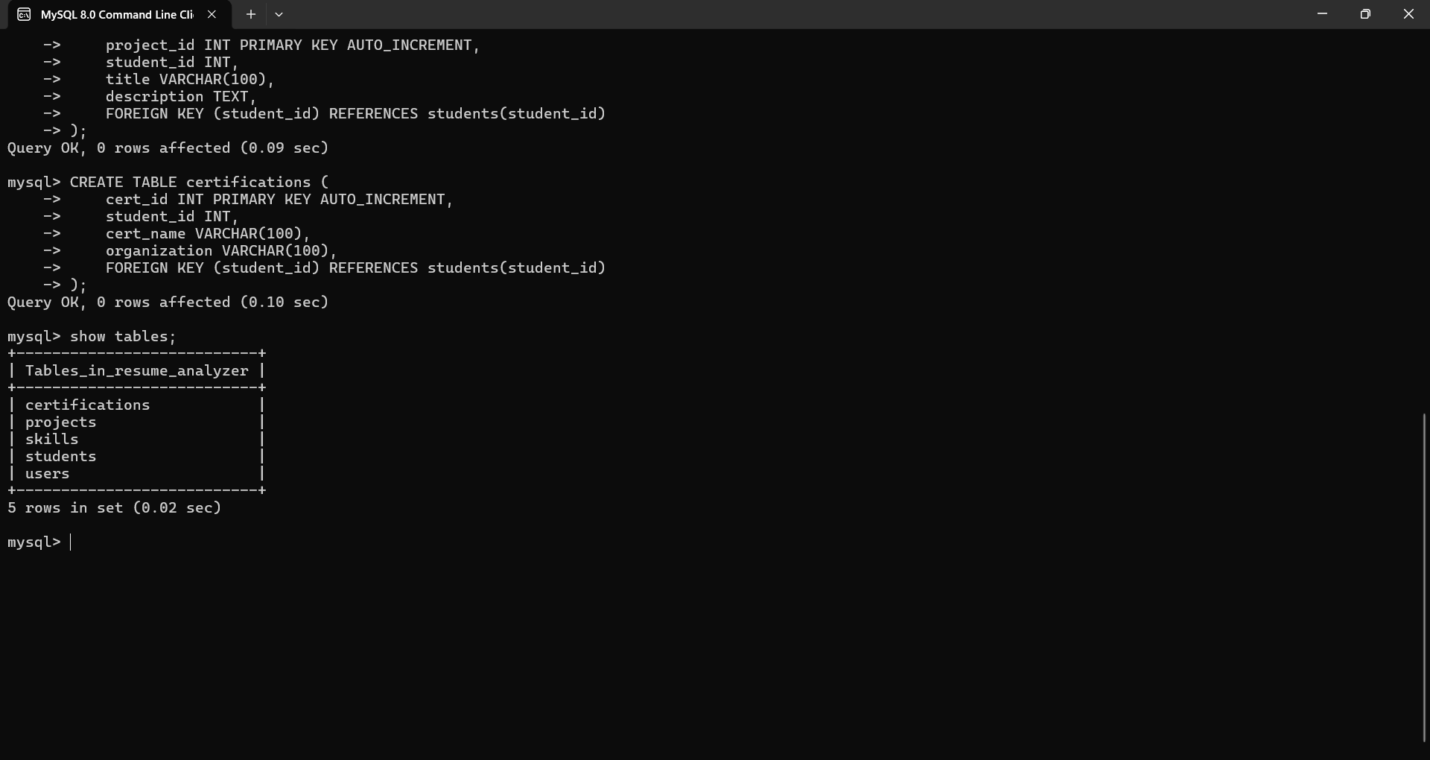

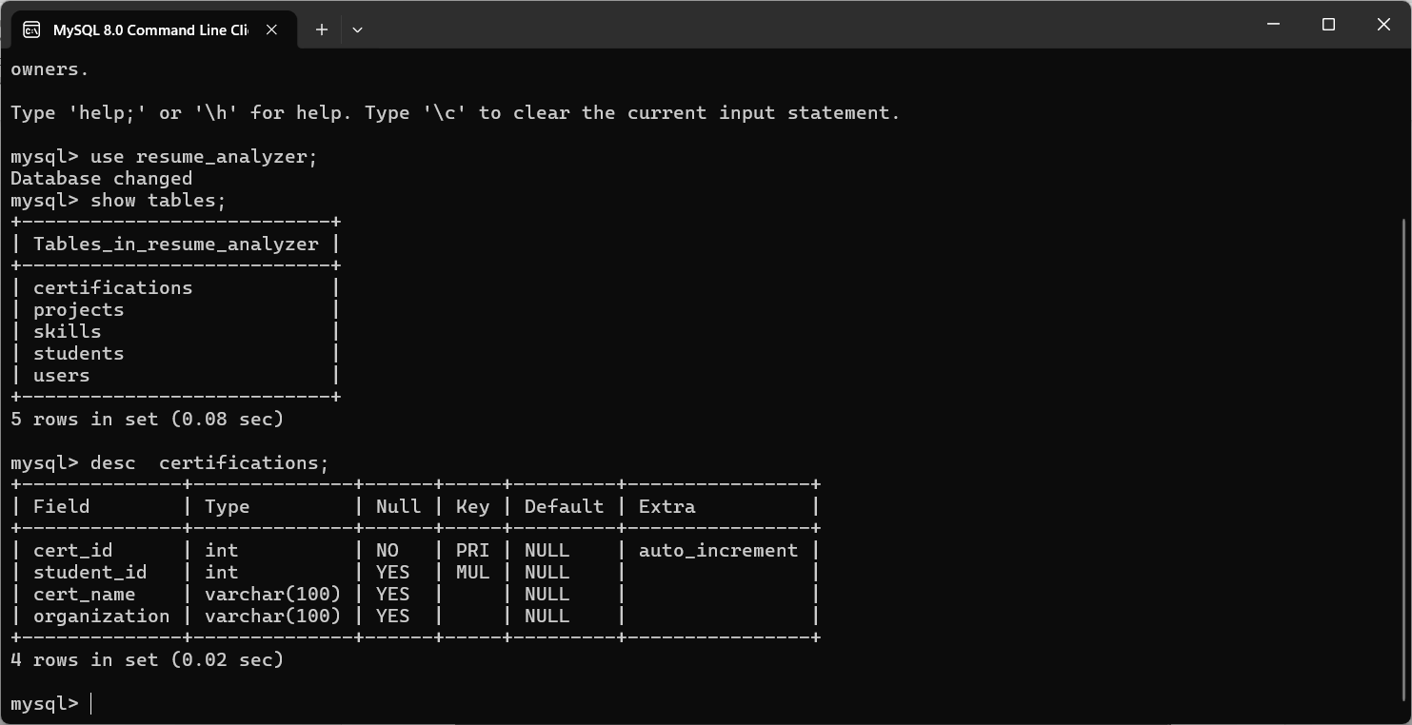

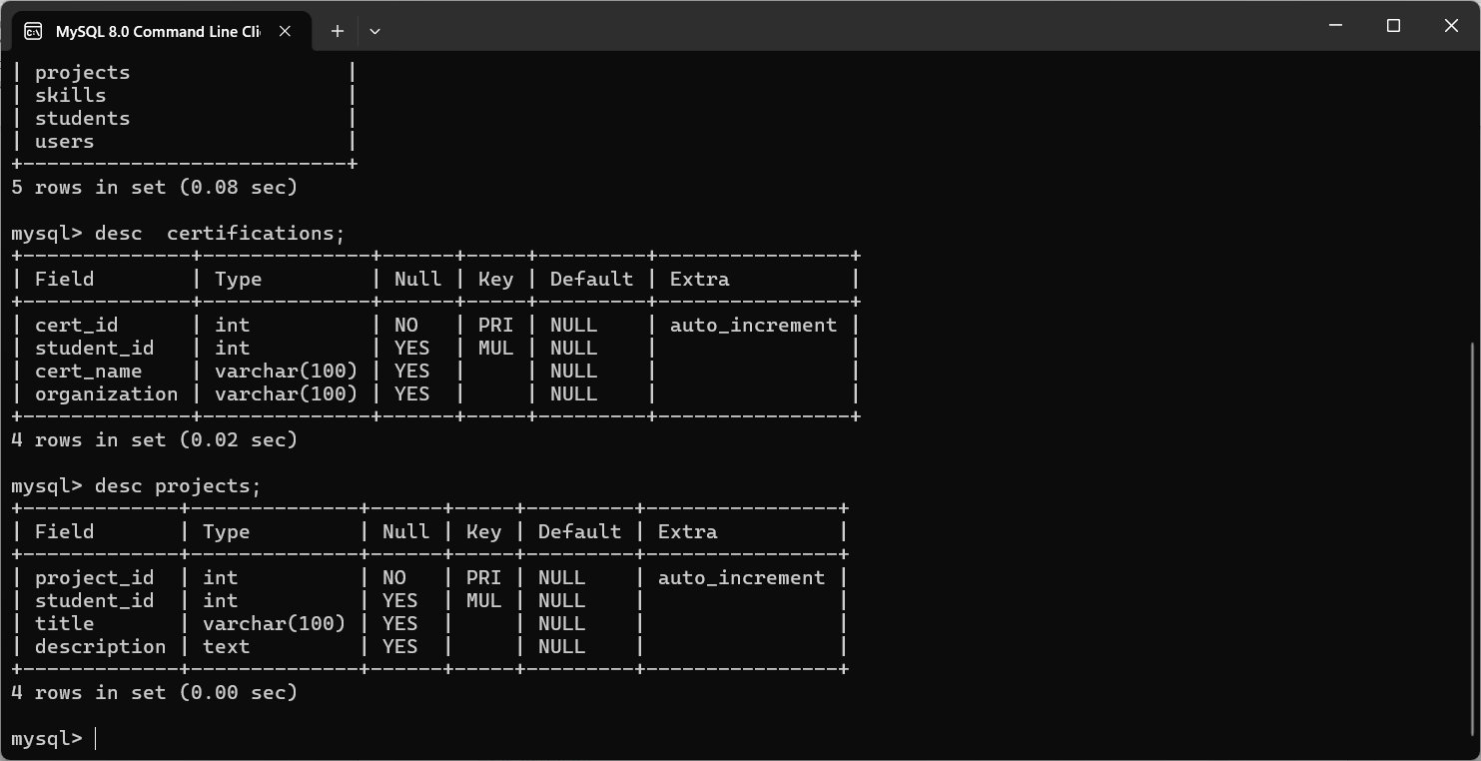

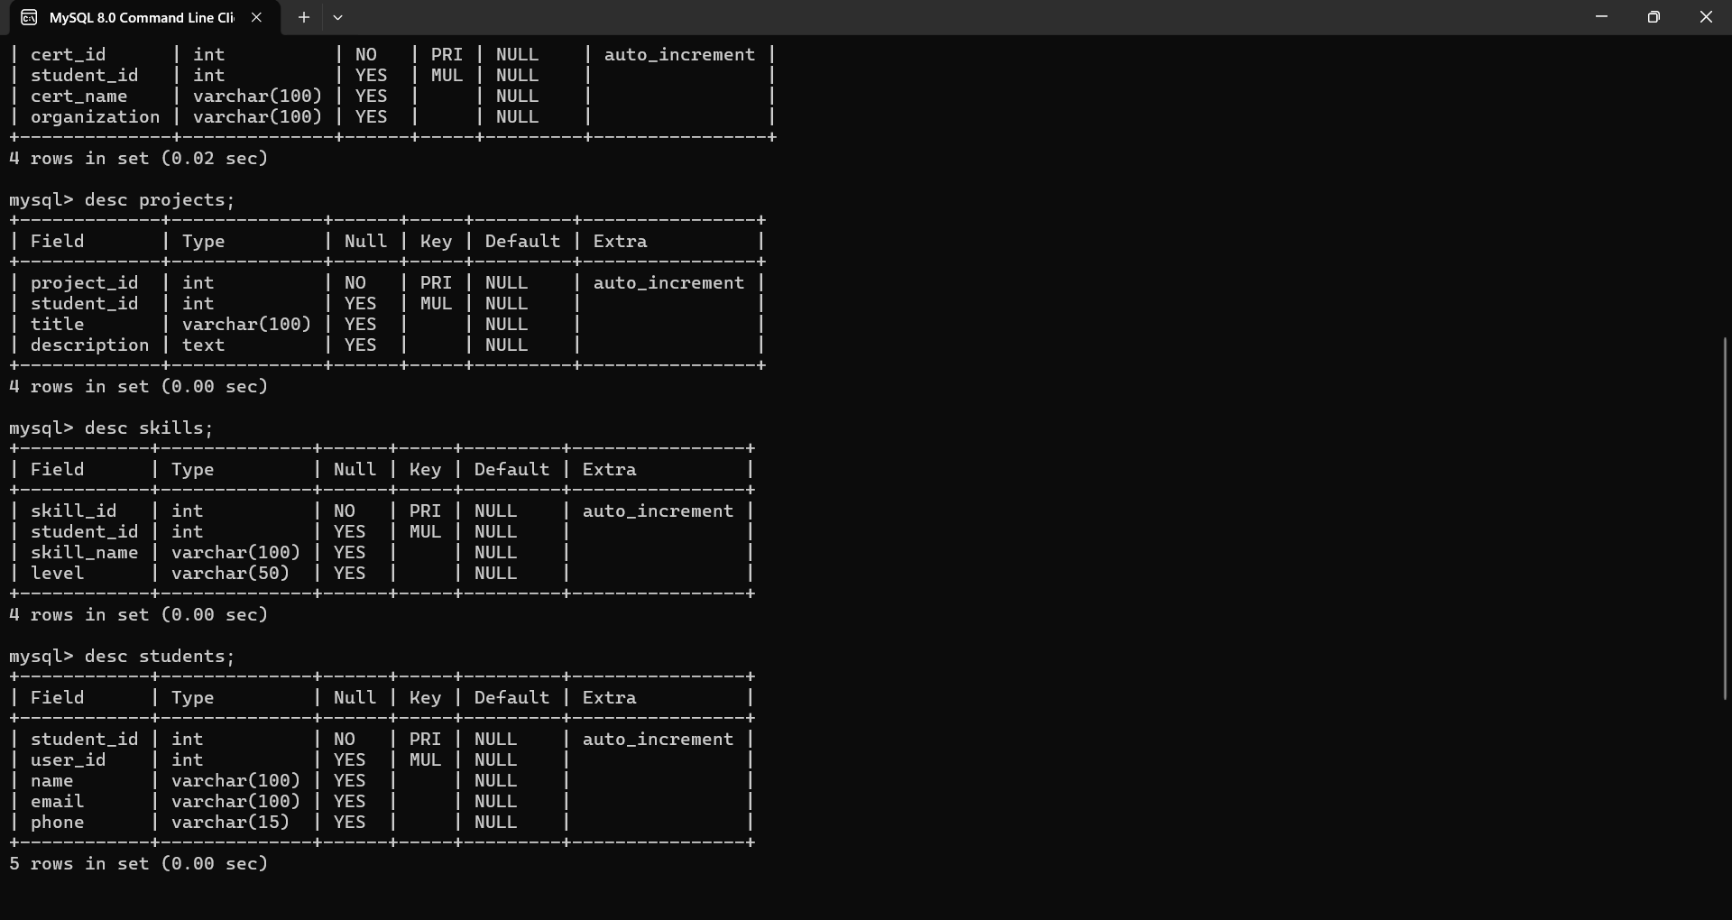

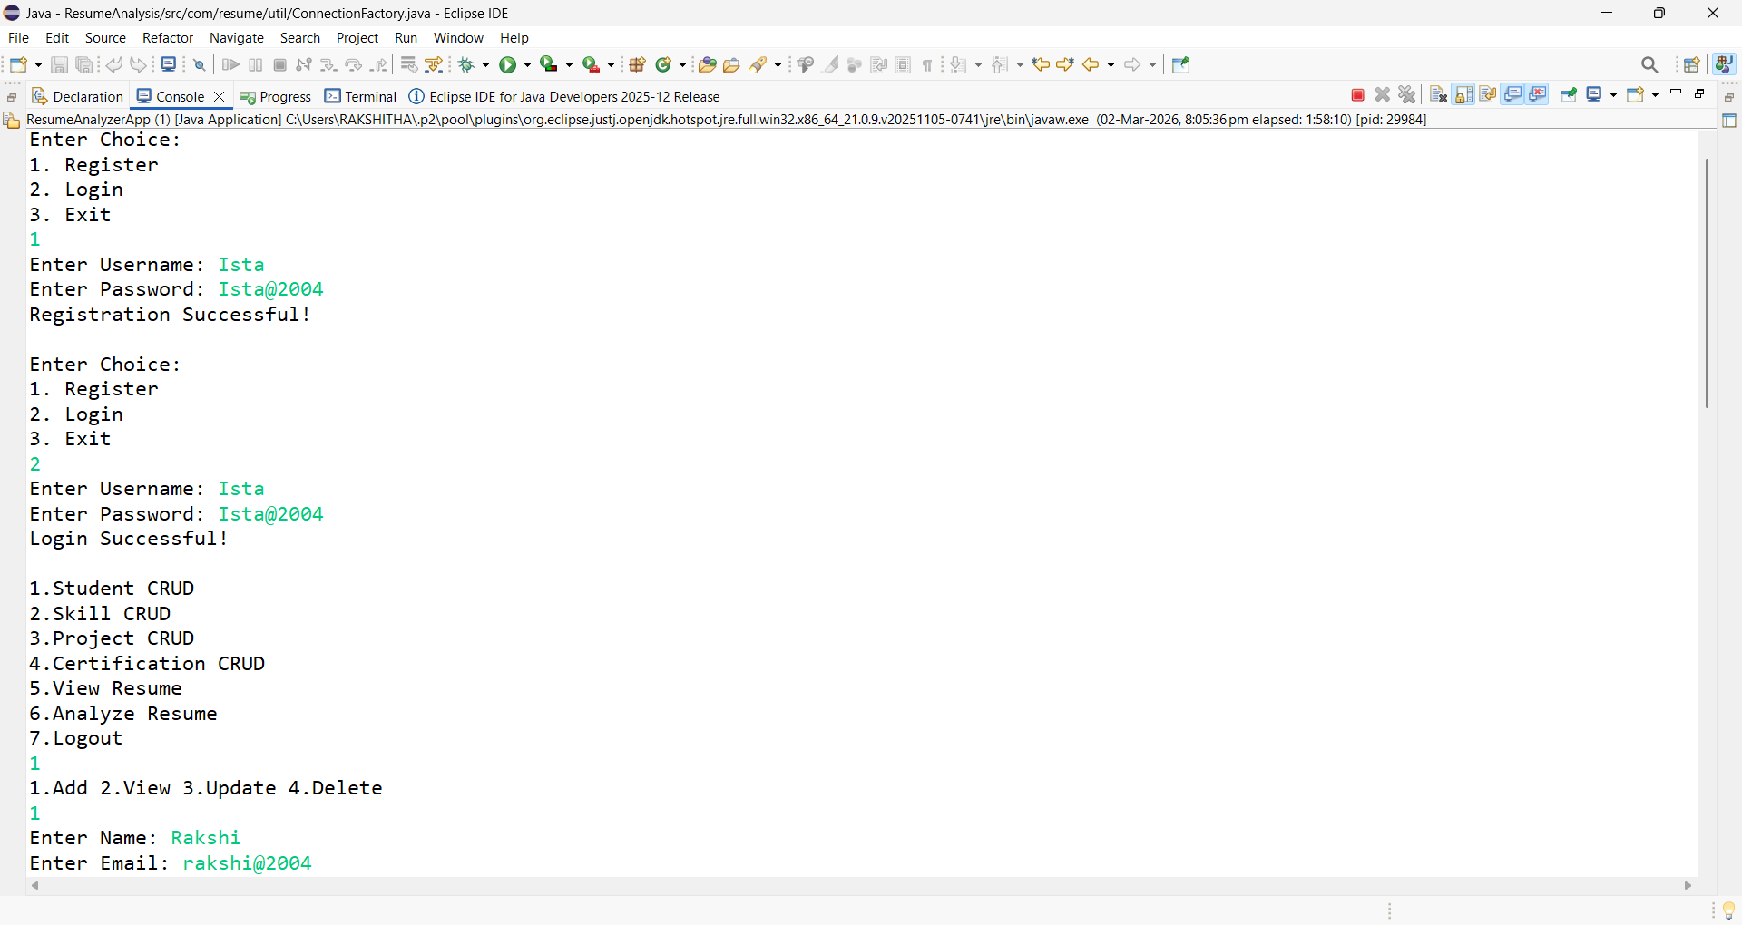

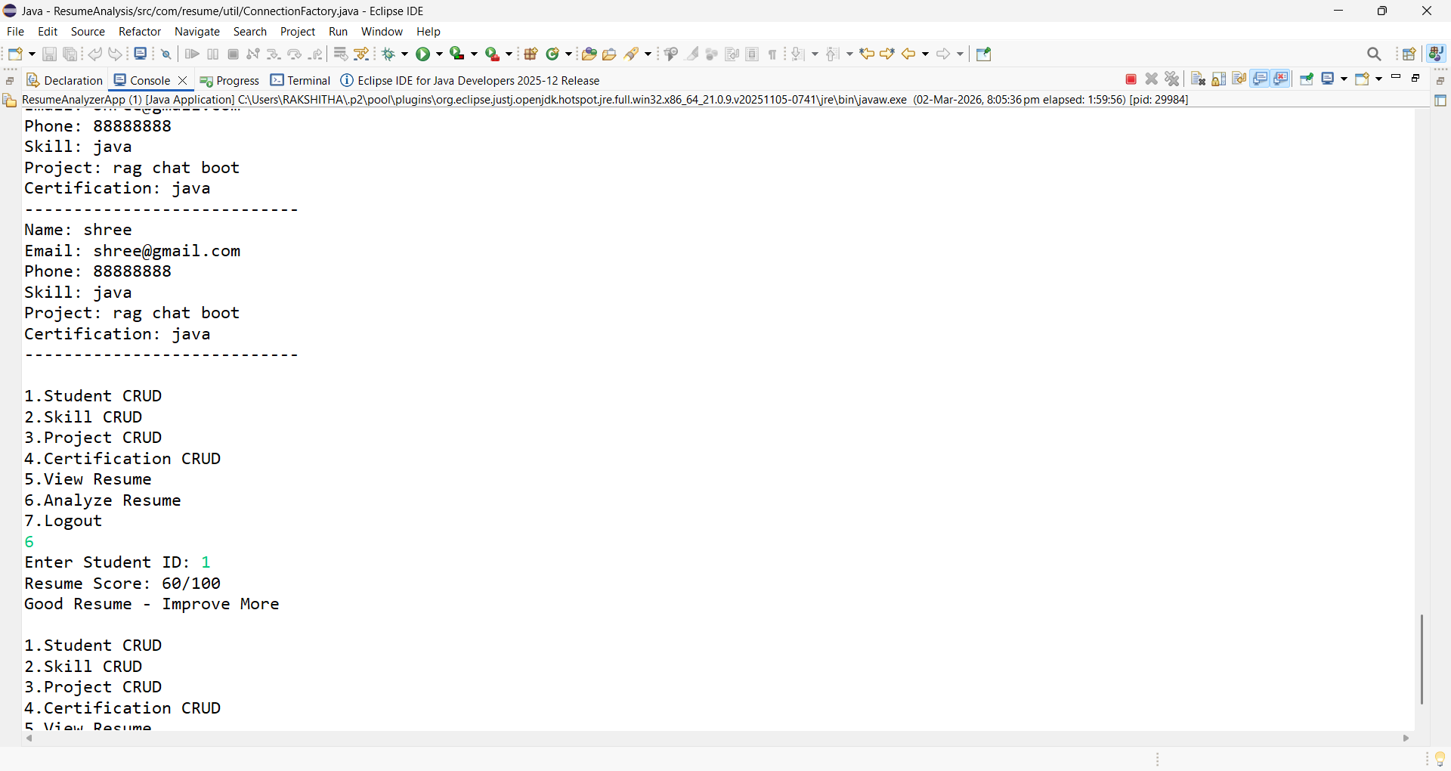

Final Conclusion
The Student Resume Readiness Analyzer is a console-based Java application developed to provide a structured and efficient system for managing and evaluating student resume information. The project successfully integrates Core Java, JDBC, MySQL, DAO design pattern, and Factory pattern to build a modular and maintainable system.
The application allows users to register and log in securely, manage student details, and perform full CRUD operations on skills, projects, and certifications. The implementation of SQL JOIN queries enables the system to generate a complete resume view by combining data from multiple related tables. Additionally, the resume analysis feature evaluates resume readiness based on predefined criteria and provides meaningful feedback to the user.
Through this project, key software engineering principles such as layered architecture, database normalization, encapsulation, and separation of concerns have been effectively implemented. The use of design patterns improves code organization, scalability, and maintainability.
The system meets all the defined functional and non-functional requirements. It operates efficiently within minimal hardware and software requirements, making it cost-effective and easy to deploy in an academic environment.
Although the current implementation is console-based and provides basic resume analysis, it lays a strong foundation for future enhancements such as GUI development, web-based deployment, advanced resume scoring algorithms, and integration with job recommendation systems.
In conclusion, the Student Resume Readiness Analyzer successfully demonstrates practical knowledge of Java programming, database connectivity, SQL operations, and design patterns while providing a useful tool for students to assess and improve their resume readiness.

